# Windows Phone 8.1 Application Development Project Report

## Rui HUANG

### rui.huang@metropolia.fi

1. Introducation

RuiNote is one note application to give you easy style to record your daily life events. The user can put different types of files as text, photos, voice locally in the phone or you can also save them into Microsoft OneDrive cloud service.

1. Development Details
   1. What Is Done

RuiNote now supports the following features:

* Login and Logout with your Microsoft account
* Metro interface and theme support
* Editing and Viewing text note, (only text file recently)

Following specification has been implemented in recent release:

Localization: en-US and fi-FI, MVVM architecture, Navigation, Data Persistence, App Bar, OneDrive authentication

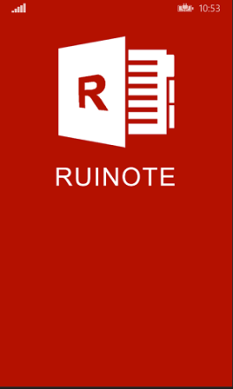 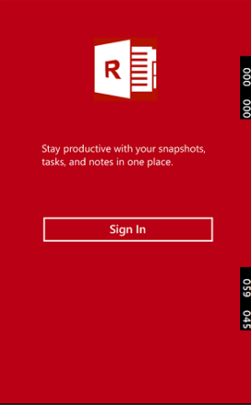  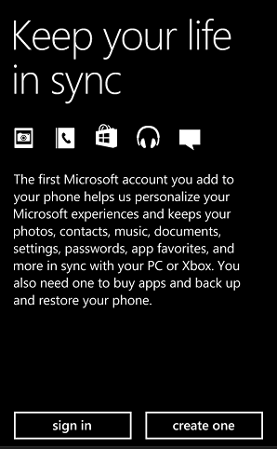 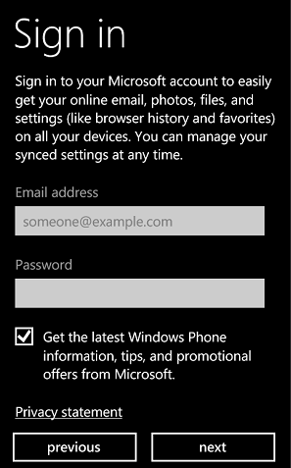

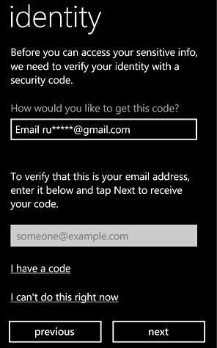 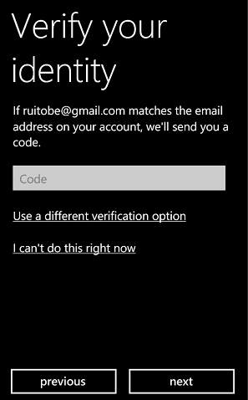 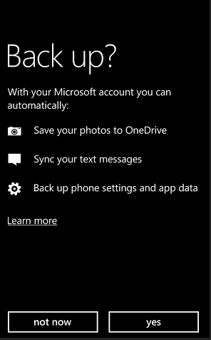 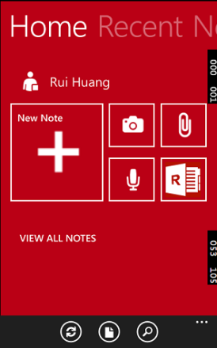 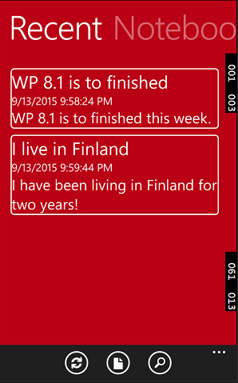

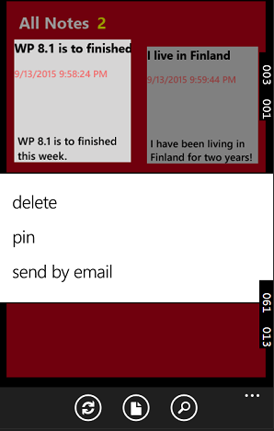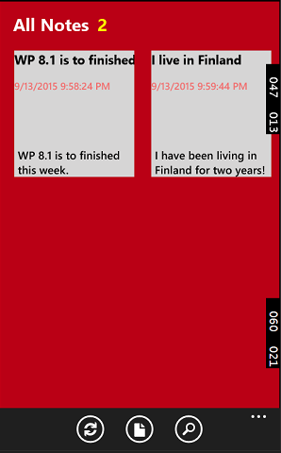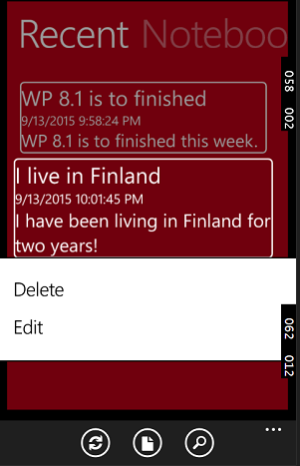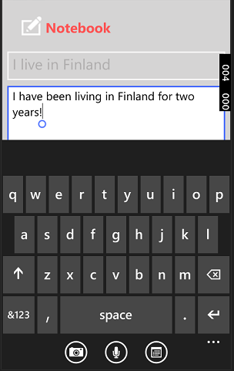

* 1. What Is Missing

The feature of cloud synchronization is not implemented.

1. Open Libraies and Open Source
   1. Open Libraies

[Windows Live SDK 5.6](https://www.nuget.org/packages/LiveSDK)

[MVVM Light Toolkit](https://mvvmlight.codeplex.com/)

[Cimbalino ToolKit](http://cimbalino.org/)

* 1. Reference Code for Microsoft Authentication

<http://www.c-sharpcorner.com/UploadFile/3789b7/authentication-using-facebook-google-and-microsoft-account826/>